Crypto Market Analysis Report
Date: 12-02-2025

1. Introduction
This report provides an analysis of the top 5 cryptocurrencies based on market capitalization, fetched using the CoinGecko API. The data is updated every 5 minutes and displayed in an Excel sheet.

2. Data Collection
The data was retrieved using Python and the CoinGecko API, collecting key attributes such as:
- Cryptocurrency Name & Symbol
- Current Price (in USD)
- Market Capitalization
- 24h Trading Volume
- 24h Price Change (%)

3. Analysis & Insights
3.1 Top 5 Cryptocurrencies by Market Cap
The top 5 cryptocurrencies based on market capitalization at the last update were:
Rank | Name | Market Cap (USD)
1 | Bitcoin | $1.9067T
2 | Ethereum | $318.89B
3 | Tether | $141.87B
4 | XRP | $141.00B
5 | Solana | $96.83B
(Refer to the Excel Screenshot Below)
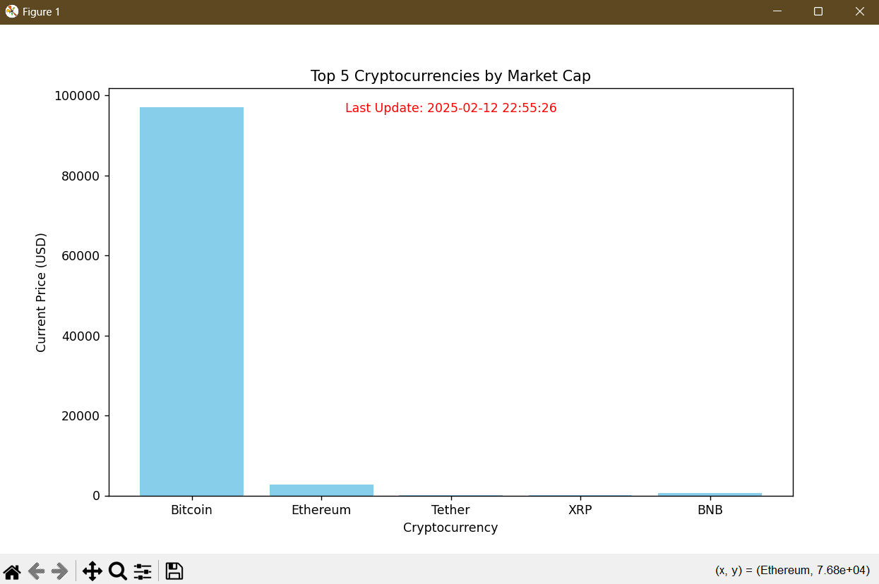

3.2 Price Changes & Trends
- Average Price: The average price of the top 5 cryptocurrencies was $19,816.00.
- Highest 24h Change: XRP had the highest price increase of 0.16329% in the last 24 hours.
- Lowest 24h Change: Solana had the biggest decline of -2.55125% in the last 24 hours.
(Refer to the Excel Screenshot Below)
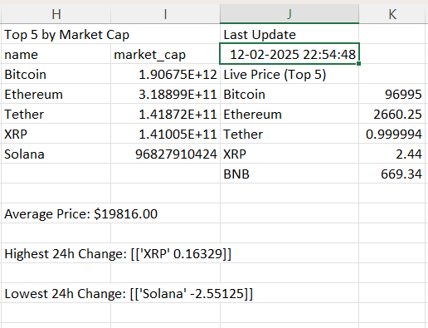

4. Live Updating Excel Sheet
The Excel sheet displays real-time cryptocurrency data with automatic updates every 5 minutes. It includes:
- A tabular representation of the latest market data.
- Separate sections for market analysis and trends.
- A timestamp of the last update: 12-02-2025 22:54:48
Google Drive - Live Excel Link: Live Excel Sheet (Ctrl + click to follow link)
Copy and paste this URL in the browser if the above hyperlink doesn’t work - https://docs.google.com/spreadsheets/d/1w_MwO2BcO5Xb6mJWLvHyqfHmCfN3t14I/edit?gid=1624661169#gid=1624661169

5. Data Visualization
A bar chart representation of the Top 5 Cryptocurrencies by Market Cap is displayed below:

6. Conclusion
This project successfully demonstrates the integration of live cryptocurrency data into an Excel sheet for real-time tracking and analysis. The analysis highlights major market trends, allowing users to observe price movements and market capitalization changes efficiently.

Prepared By: Dadi Devaki Dhanasree
Submission Date: 12-02-2025

